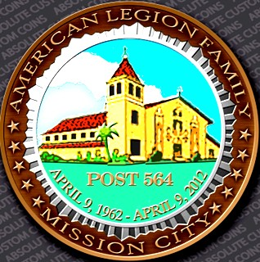

Post 564

-

Mission City News

Bulletin

Santa Clara CA



**Chartered 9 April**

**1962**

**July 2025 Issue**

**Mission City Post #564 Dues have gone up to #55.00,**

**At the AML state Convention Department, this last June voted on raising**

**The dues, has nothing to do with the Post. We just follow what they charge**

**The Commander Speaks**

I hope everyone had a safe and happy Fourth of July with family and friends. It’s been a busy month working around the post getting things done. I would like to thank Ronald Phillips for helping. I would like to know if anyone else is willing to donate a little of their time to help out. I know how busy life gets. Sometimes it’s hard to predict when you will have time to give. Just remember that every little bit helps.

As a reminder, our post meeting will be July 23, 2025. Our new hours for our meeting is dinner from 6-7:00 with Meeting starting at 7 PM. I’m

looking forward to seeing everyone there. Remember the post belongs to all

of us and we are looking at ways of improving membership participation and having events. I would like all members to send any suggestions they have.

You can send them to my email which is lindaguida10@msn.com.

Post commander Antonio Guida

From the Desk of the 1st Vice

From the desk of the 1st Vice

Hello fellow Legionnaires! And a very busy month this has been. First, let me wish all Veterans a Happy [belated] 4th of July.

I hope it was safe and fun with BBQs and Fireworks. The month of July is moving right along and there is not slowing down.

There is at least one event I believe is upcoming and that will be our Installation of Officers July 11, 2025, at Mission City Post# 564 from 17:0020:00.

To strengthen my body and my mind, I continue to go and see my Primary Care Doctor, and I highly recommend we as Veterans do the same. I have also chosen to utilize my VA Education Benefits, G.I. Bill to keep my mind strong.

As you know, some of us are experiencing hard times, as some personnel are asked to depart the Federal Government.

Please have a plan and make contact to whomever might be able to assist in these challenging times.

As I write this posting, I think of Military OneSource [https:// www.militaryonesource.mil/,](https://www.militaryonesource.mil/) Chaplain and Wellness support Groups, Menlo Park Behavioral Health. and lets not forget we have Volunteer Organizations: USO [https:// www.uso.org/](https://www.uso.org/) , American Red Cross [https://www.redcross.org/volunteer/ become-a-volunteer.html](https://www.redcross.org/volunteer/become-a-volunteer.html) , this includes giving blood and or support to the personnel in Texas affected by Floods, and we still have our Sons of the American Legion, A.L. Auxiliary, and Legion Riders.

Please check us out from time-to-time at Post# 564 and volunteer or throw your hat in the ring for one of our vacant positions: Chaplain, VSO, Sergeant of Arms, Finance Officer. thank you and stay safe this weekend.

v/r Julius Boyd 1st Vice

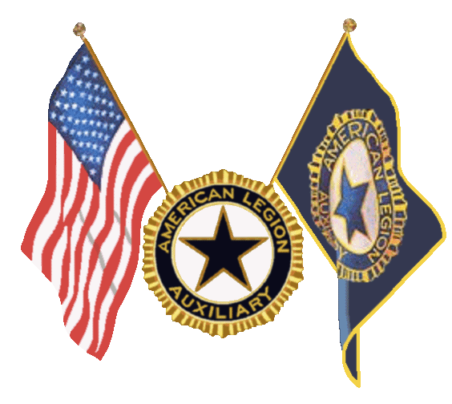

To ALA Unit 564 Members

After a challenging year as Unit 564 Secretary and Treasurer, a few of us could not achieve our goals for 2024-2025. I ensured the information was sent out to those on my email lists. I enjoyed extending the listing to other members in the district, so some of the feedback was positive and helpful.

With the support of others, I had the opportunity to attend the California Department's End-of-Year (DEC) Convention on June 27-29, 2025. It was an exciting event and a great time to meet other organization members. I enjoyed seeing the American Legionnaires join in the exact location.

Congratulations to Susan Baker, Department President 2025-2026. This year's theme is “Hats off to Heroes, Salute to our Heroes.“Her colors are red, black, and white. She and the team will bring great things and leadership skills to make it a great year. Please check the department website, [calegionaux.org,](http://calegionaux.org/) and Facebook for more information, events, and photos.

A special thank you goes to the American Legion Post 564, Jan McCormick, Unit

Chaplain Jennifer Fanucchi, Executive Woman, and other unit members from District 13 for their support of the VA&R and VAVS Hospital Program. We can’t do it without your help.

As this year ends, to the members, may you have an opportunity to bring your experience and knowledge to work together to keep the unit engaged in the ALA Mission.

We aim to empower our membership to achieve personal fulfillment through Service, Not Self.



Hello all. Well the weather has finally turned for the better and has given the

District 13 Riders a chance to get out and ride a little . We started with an Escort for Operation Surf, a program that help veterans heal from mental and physical wounds. On march 23rd we had 3 riders, Mike Picazzo, Brian Tarbet, and Tony Pettronelli, All 3 riders escorted the veterans from San Jose Airport to Santa Cruz. The Mission was a total success. April 11th-13th was the American Legion Riders convention in Hollister. We were represented by 3 Delegates to the convention : Tony Pettronelli,Robert Lopez, and Brian Tarbet. We were also represented as Sergeant of Arms by our own Mike Gallo. sounds like they all had a great time and brought back some useful information .

Finally, The town of Hollister opened up and let the 4th of July Rally to happened. We had a great turn out on Saturday, the 5th. We left post 564 with 7 riders and picked up an 8th rider along the way. We all met for a great breakfast in downtown Hollister and checked out the vendors, and enjoyed a cold ones before we came home. It was a nice Rally. It was a great ride down and a great ride back and we did a safety check and everyone got home safe and sound.

As a special interest I posted a picture the guy who turned whatever bike he was riding into a jet ski on wheels . Ingenious ,but don’t think I’d take that on the freeway.

Mark Corbet District 13 Road Captain.

